FIRST 2022 28th year!!! Oh Yeah!!!

Team Meeting 12/16/22 FIRST Website-www.firstinpires.org Team website-www.tj2.org
-------------------------------------------------------------------------------------------------------------------------------
Student Leadership Board: Grant W.(Captain) , Rohan S., Evan G. Nathaniel B., Evan S., Silver D., Ben M-H.
Coaches , Engineers & Volunteers: Mrs. Calef ( Lcalef@bridge-rayn.org),Mrs. Delmonte, Ms. Jerome, Mr. Jahnke, Mr. Stewart, Mrs. Wood, Mr.Delmonte, Mr. Calef, Mr. LaMothe, Jen Flannery, Mr. Nick Avtges, Pat Koczela, Tom Calef, Steve Viera, Heather Charland, Doug Stewart, Brad Wall, Amy Sauger, Eric Theberge, Mrs. Theberge, Trevor Kelly, Paul Terrasi, Dr. Joe Johnson , Ben Warwick, Dr. Andras Pungor, Bob Spurr, Shay Mitton, Connor Spurr
Friends of TJ2 Robotics -FOTJ2R – a 5013C friends support group - President: Scott Rubin, Treasurer: Kerri Spurr, Secretary: Heather Charland – Board of Directors: Bill Wood, Heather Charland, Brad Wall, Nick Avtges, Eric Theberge, Doug Stewart, Scott Rubin, Bob Spurr, Kerri Spurr, Don DeLutis, and Gretchen DeLutis.
Twitter page https://twitter.com/frcteam88 Google Classroom : z6pvwas
-------------------------------------------------------------------------------------------------------------------------------ATTENTION: When shopping on Amazon.com, if instead you go to www.smile.amazon.com and declare Friends of TJ2 Robotics, Inc., your charity…..0.5% of every purchase will to FOTJ2R without costing you anything!!!!! Please tell all your family and friends.
Team Meetings: Fridays bi-weekly at 2:15pm BRRHS Rm H103
Meeting agendas will be posted on our website at https://www.tj2.org/team-meetings
FIRST Scholarships - https://www.firstinspires.org/alumni/scholarships
Group Meetings - log hours- use QR scan- should be in group meeting rooms
Veterans -min 30 hours, Rookies- min 20 hours to be on the travel team. Team meetings do not count. PR/Outreach hours count double.
www.tj2.org/calendar
You do not need to attend all of these meetings. You need to attend the team meetings on Friday. You may and are welcome to choose to attend any of the group meetings listed above.
Team Holiday Party -
F114 after school 12/16 - bring gift <=$10- sign up for food item - slack general, family slack, classroom….. Drop off location is room B204-before school.

Auction- $11,000+ profit!!!! Way to go!!!!!

Fundraising Events:
Canal Day fundraiser – Monies should be in to Ms. Jerome. Please make checks out to FOTJ2R, Inc.

Contact Community businesses for sponsorships- 9/1-1/7/23. Make sure that if you signed up for a business that you follow through with that business! The master list is located in Ms. Jerome’s classroom!
Fundraising Status - team minimums must be met by Jan 7th. All members must determine fundraising plan with Ms. Jerome if minimum won’t be met by Jan 7th - this is your responsibility as a member of TJ². All forms must be turned in by this time as well. Team status will be determined at this time. !!!!STIMS needs to be complete!!!!

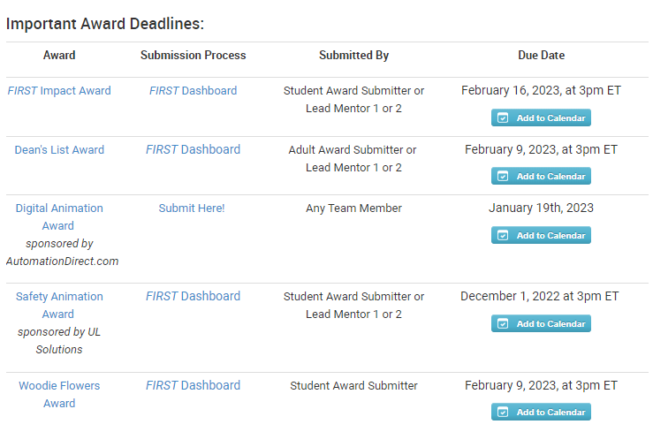

Review of Ethics Code, vote to accept, lanyard creation Code of Ethics 2023 pass in signed code of ethics to Ms. Jerome H103. Due 11/4/22

Kickoff
Saturday, Jan 7th- 11:30am in the BRRHS Lecture Hall. Mandatory for all team members 11:30am - end of broadcast (2pm??)- option strategy meeting until 5pm.
Sunday, Jan 8th - noon-3pm in BRRHS Lecture Hall- mandatory for all students. Mentor and Captain meeting 3-5pm in BRRHS Lecture Hall.

TEAM Function and Structure
-Monies raised go to student account- see Ms. Jerome for totals as needed.
-Team Ranking List ….it is happening……log those hours!! Fundraise!!! 43 students and growing!!
-Students will be required to fundraise $400 for non-travel team, $700 for travel team by Kickoff-Jan 7.
-record your hours!!
-help connect your team with a local business sponsor.

