FIRST 2022 28th year!!! Oh Yeah!!!

Team Meeting 11/18/22 FIRST Website-www.firstinpires.org Team website-www.tj2.org
-------------------------------------------------------------------------------------------------------------------------------
Student Leadership Board: Grant W. , Rohan S., Evan G. Nathaniel B., Evan S., Silver D., Ben M_H.
Coaches , Engineers & Volunteers: Mrs. Calef ( Lcalef@bridge-rayn.org),Mrs. Delmonte, Ms. Jerome, Mr. Jahnke, Mr. Stewart, Mrs. Wood, Mr.Delmonte, Mr. Calef, Mr. LaMothe, Jen Flannery, Mr. Nick Avtges, Pat Koczela, Tom Calef, Steve Viera, Heather Charland, Doug Stewart, Brad Wall, Amy Sauger, Eric Theberge, Mrs. Theberge, Trevor Kelly, Paul Terrasi, Dr. Joe Johnson , Ben Warwick, Dr. Andras Pungor, Bob Spurr, Shay Mitton, Connor Spurr
Friends of TJ2 Robotics -FOTJ2R – a 5013C friends support group - President: Scott Rubin, Treasurer: Kerri Spurr, Secretary: Heather Charland – Board of Directors: Bill Wood, Heather Charland, Brad Wall, Nick Avtges, Eric Theberge, Doug Stewart, Scott Rubin, Bob Spurr, Kerri Spurr, Don DeLutis, and Gretchen DeLutis.
Twitter page https://twitter.com/frcteam88 Google Classroom : z6pvwas
-------------------------------------------------------------------------------------------------------------------------------ATTENTION: When shopping on Amazon.com, if instead you go to www.smile.amazon.com and declare Friends of TJ2 Robotics, Inc., your charity…..0.5% of every purchase will to FOTJ2R without costing you anything!!!!! Please tell all your family and friends.
Team Meetings: Fridays bi-weekly at 2:15pm BRRHS Rm H103
Meeting agendas will be posted on our website at https://www.tj2.org/team-meetings
FIRST Scholarship - Open Date: Wednesday, September 1, 2022 -APPLY APPLY APPLY!!!!
****The Amazon Future Engineer Scholarship Program is now open and this *******
life-changing opportunity will last a lifetime! The Program awards 400 high school seniors who are planning to pursue an undergraduate degree in engineering or computer science with a $40,000 scholarship for college, plus a guaranteed paid internship at Amazon. Applications are open until January 20, 2023. Learn how to apply.

Group Meetings - log hours- use QR scan- should be in group meeting rooms
Veterans -min 30 hours, Rookies- min 20 hours to be on the travel team. Team meetings do not count. PR/Outreach hours count double.
TJ² Art – Mondays- BRRHS Rm B204 2:15-4pm
TJ² Strategy meetings – 11/10 5pm-6pm BRRHS D134
TJ² PR/Outreach meetings- Tuesday 6-7pm zoom, Fridays 2:45-4pm BRRHS D134 as needed
TJ² Programming -Thursdays 7-9pm at build meetings BRRHS Rm F114
TJ² Team Meetings – biweekly Fridays – BRRHS H103 2:15-2:40
TJ² Build – ON CALENDAR -www.tj2.org/calendar
TJ² CAD Meetings Tuesdays on zoom 7-9pm
TJ² Build Training Meetings - Fridays 2-4pm BRRHS D134. (after team meetings)
You do not need to attend all of these meetings. You need to attend the team meetings on Friday. You may and are welcome to choose to attend any of the group meetings listed above.
NOTE: Meetings are canceled for 11/24-25 due to Thanksgiving
Group Update
Auction
Thursday 12/1 2-6pm- this is required of all TJ2 members
After school- meeting in H103 - bring items to Vets Club
Friday 12/2 - students sign up to attend and help at auction - pizza is provided for students
Students wear tie dye
Students arrive at Vets club at 5pm to finalize set up of auction
Vets Club - 85 Cottage ST, Bridgewater, MA.
Students report to caterer for server instruction
Students will be assigned duties and stations
Students will serve the meal and then clear the tables
Students assist with auction powerpoint data entry
Students will assist with Trivia game
Students will assist with Raffle Auction
Students will help gather auction items for purchasers
Students will help pick up the hall…..hopefully concluding by 10:30pm or when complete.

Auction Item totals will be given at following team meeting 12/16

Awards Update
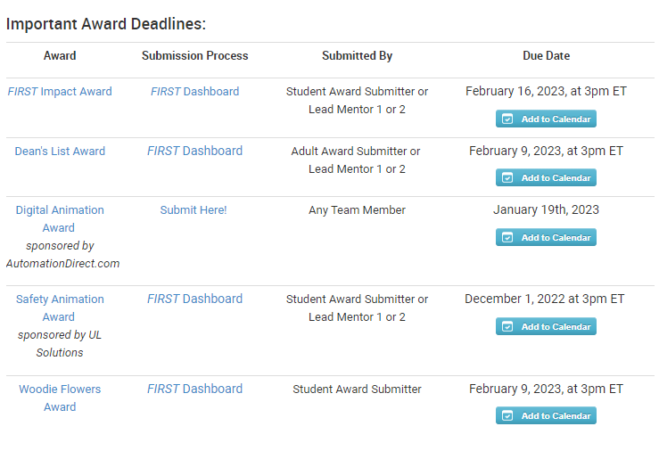

Review of Ethics Code, vote to accept, lanyard creation Code of Ethics 2023 pass in signed code of ethics to Ms. Jerome H103. Due 11/4/22

Fundraising Events:
Canal Day fundraiser – Monies should be in to Ms. Jerome. Please make checks out to FOTJ2R, Inc.

Contact Community businesses for sponsorships- 9/1-1/7/23.

Annual Auction fundraiser - Bridgewater Vets Club - Friday, December 2, 2022, set up 12/1 after school.
Each student must bring in an auction item worth at least $25. These are due 11/18. Please fill in the auction item sheet when you pass in your donation by 11/18, even if the physical item is not in. Items that can not be brought into the school. Group meetings and auction item presentations.
Please see Ms. Jerome. TICKETS ARE ON SALE NOW!!!! Fill in the google form on our Classroom and bring in your money to Ms. Jerome, H103 to secure these tickets. Tickets sales end by 11/18.

TEAM Function and Structure
-Monies raised go to student account- see Ms. Jerome for totals as needed.
-Team Ranking List ….it is happening……log those hours!! Fundraise!!! 43 students and growing!!
-Students will be required to fundraise $400 for non-travel team, $700 for travel team by Kickoff-Jan 7.
-record your hours
-get your auction item in!
-help connect your team with a local business sponsor.

