Ethics and Robotics Teams – a Lesson!
Goal: to develop a relevant code of ethics that students own and embrace as their own.
-to develop a method of keeping the code alive on the team
-to develop a method of passing this code to future teams, making it an important tradition of the team
TJ2 Member Code
General Guidelines for Team member
- Contribute to welcoming atmosphere and feel of the team
- Do not misuse team or school equipment/facilities
- Value honesty and integrity
- Absolutely never bully, exclude, or discriminate against teammates, members of FIRST Robotics or anyone
- Have knowledge of all rules and regulations both in your school and at FIRST events and report any violations of them
- Fulfill all obligations and responsibilities to the best of your ability
- Accept responsibility for your actions
- Understand and follow the general ethics rules of FIRST
- Code of Conduct FIRST Robotics
FYI
The FIRST mission is to inspire a generation of science and technology leaders who are both gracious and professional. This FIRST Code of Conduct lists some of the basic behaviors mentors, coaches, volunteers, team members, affiliate partners, contractors, staff, and other participants should adhere to while participating in FIRST activities.
- Exhibit Gracious Professionalism® at all times. Gracious Professionalism is a way of doing things that encourages high-quality work, emphasizes the value of others, and respects individuals and the community. With Gracious Professionalism, fierce competition and mutual gain are not separate notions.
- Ensure the safety of all participants in FIRST activities.
- Not engage in any form of bullying, harassment, use of profane or insulting language, or any actual or threatened violence.
- Adhere to all FIRST Youth Protection Program (YPP) policies.
- Report any unsafe behavior to event or local FIRST leadership.
Persons who do not comply with this Code of Conduct may be barred from participating in FIRST activities.General ethics for Leaders
General Ethics for Leaders
- Encourage the team and help members in understanding their own roles and ethics
- Help create opportunities for others to learn and experience all aspects of FIRST and STEAM as a whole
- Assist struggling or isolated members as well as develop trust with everyone
- Role model acceptable behavior by following all ethical rules and promoting an environment of toleration and acceptance
- Communicate and interact with all members and aspects of the team
Ethics for Competitions
- Always act with Gracious Professionalism
- Help others whenever you get the chance
- Treat other teams with respect and kindness
- Lift others up rather than tear them down
- Always keep your cool
- Do your best
- Behave responsibly
Ethics for interacting with community
- Always be truthful and thorough when making statements to the community
- Show the values of FIRST during interactions and follow all other ethical guidelines
- Act to help the public in education or the spreading of FIRST values. Always be willing to assist
- Honor to the best of your abilities all commitments and agreements between the team and an outside source
- Set a good example for FIRST and your FIRST team
Ethics for Robot Creation
- Never build something inherently dangerous or leave something in such a state that it would easily become a danger
- Assign credit where credit is due. Never allow the hard work of another to be stolen or copyright infringed.
- Ensure the workplace is completely safe and secure
- Treat every team with respect
- Offer help to others
Method to bring code to team consciousness
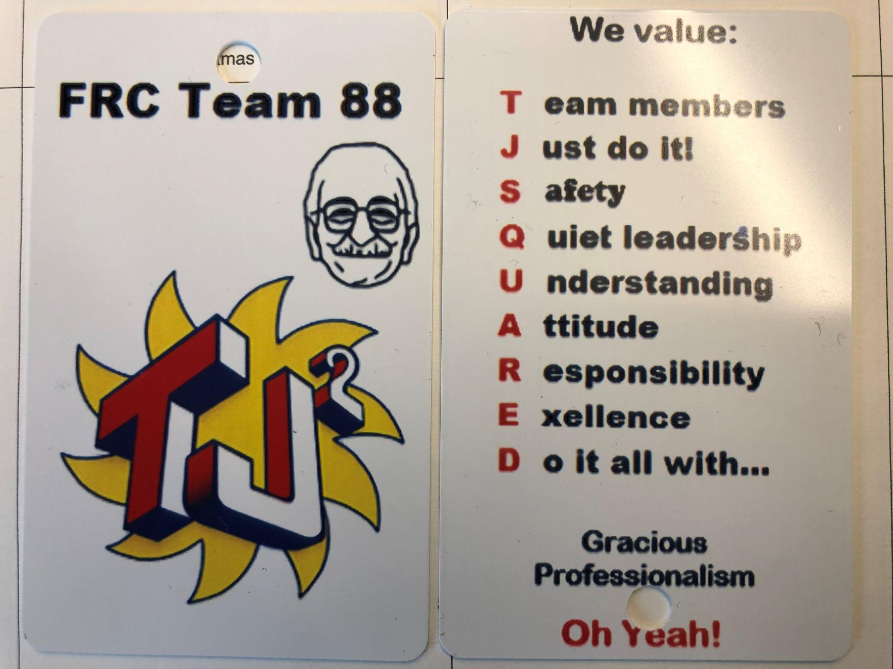
Two sided badge with TJ2 Lanyard to be worn whenever acting as part of the TJ2 Robotics Team.

Method for Future Teams
First meeting after election of captains – review code.
Team votes to adopt code
Full rewrite every four years

I agree to conduct myself in a manner that reflects this code of ethics as long as I am a member of
The BRRHS TJ2 Robotics Team FRC #88.

Member Signature ____________________________ Date ___________________________
Member Name Printed _________________________

